**Lab 04**

**21k-3881**

**Task 01**

package com.example.t1;  
import javafx.application.Application;  
import javafx.fxml.FXMLLoader;  
import javafx.scene.Scene;  
import javafx.scene.control.Button;  
import javafx.scene.control.Label;  
import javafx.scene.layout.HBox;  
import javafx.scene.layout.VBox;  
import javafx.stage.Stage;  
import java.io.IOException;  
import javafx.scene.text.Font;  
import javafx.scene.text.FontWeight;  
  
  
public class t1 extends Application{  
 private VBox va,vb;  
 private Stage st;  
 private Scene sa,sb;  
 private Button ba,bb;  
 @Override  
 public void start(Stage ps) throws IOException{  
 st=ps;  
 sa=st_one();  
 sb=st_two();  
 st.setScene(sa);  
 st.show(); }  
 private Scene st_one(){  
 Label lbl=new Label("welcome to first scene!!! ");  
 lbl.setFont(Font.*font*("arial",FontWeight.*BOLD*,20));  
 lbl.setUnderline(true);  
 ba=new Button("press for 2nd sccene");  
 ba.setMaxWidth(190);  
 ba.setFont(Font.*font*("arial",FontWeight.*BOLD*,15));  
 ba.setOnAction(e -> switch_scence (sb));  
 va=new VBox(lbl,ba);  
 sa=new Scene(va,600,100);  
 return sa; }  
 private Scene st_two(){  
 Label ll=new Label("welcome to second scene!!!");  
 ll.setFont(Font.*font*("arial",FontWeight.*BOLD*,20));  
 ll.setUnderline(true);  
 System.*out*.println("\n\n");  
 bb=new Button("press for 1st sccene");  
 bb.setMaxWidth(190);  
 bb.setFont(Font.*font*("arial",FontWeight.*BOLD*,20));  
 bb.setOnAction(e -> switch_scence (sa));  
 vb=new VBox(ll,bb);  
 sb=new Scene(vb,600,100);  
 return sb; }  
 public void switch_scence(Scene s){  
 st.setScene(s); }  
 public void b_scence(Scene s){  
 st.setScene(s); }  
 public static void main(String[] args) {  
 *launch*(); }  
}

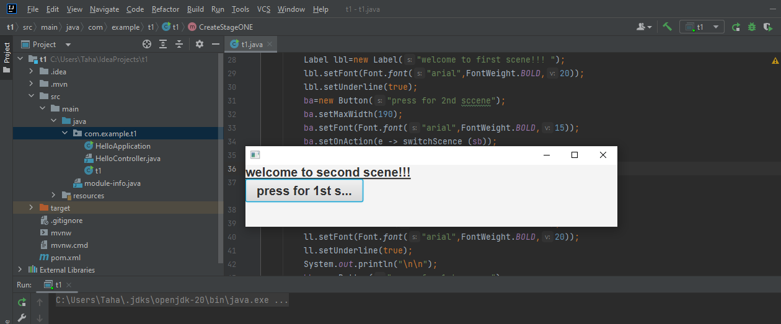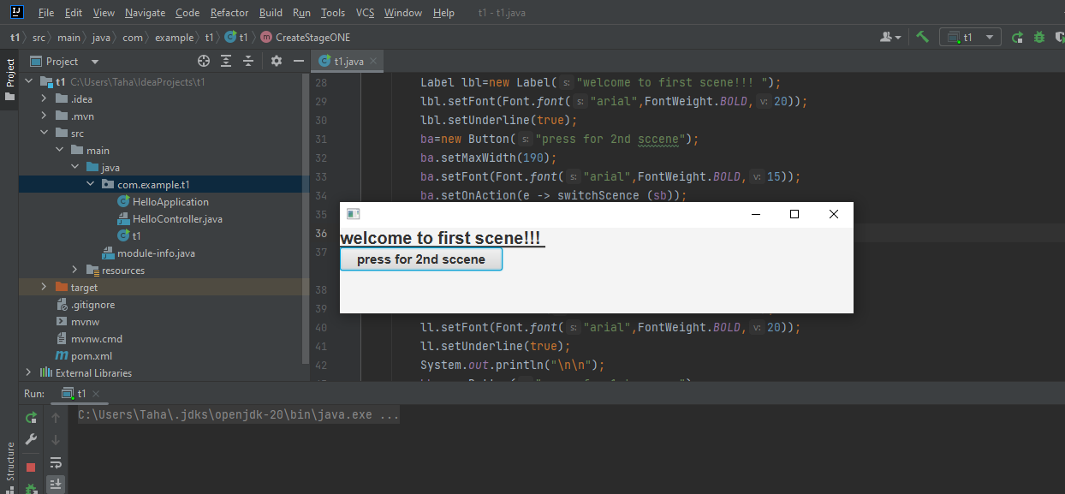

**Task 02**

package com.example.t2;  
import javafx.application.Application;  
import javafx.event.*;  
import javafx.geometry.Pos;  
import javafx.scene.*;  
import javafx.scene.Group;  
import javafx.scene.Scene;  
import javafx.scene.control.*;  
import javafx.scene.effect.*;  
import javafx.scene.layout.*;  
import javafx.stage.Stage;  
import javafx.scene.image.*;  
import javafx.scene.input.KeyCombination;  
import javafx.scene.paint.Color;  
import javafx.scene.text.*;  
public class t2 extends Application{  
 Scene sa,sb,sc;  
 String pas,use;  
 @Override  
 public void start(Stage ps){  
 sa=register();  
 sb=log_in();  
 sc=log_out();  
 ps.setScene(sa);  
 ps.show(); }  
 private Scene register(){  
 HBox pa=new HBox();  
 HBox pb=new HBox();  
 HBox pc=new HBox();  
 HBox pd=new HBox();  
 VBox pan=new VBox();  
 Label lbl=new Label("");  
 Label n=new Label("NAME = ");  
 Label e=new Label("EMAIL = ");  
 Label p=new Label("PASSWORD = ");  
 TextField txn=new TextField();  
 TextField txe=new TextField();  
 PasswordField txp=new PasswordField();  
 Label nam=new Label(" ");  
 Label em=new Label(" ");  
 Label pass = new Label(" ");  
 Button b=new Button("REGISTER!!!");  
 pan.getChildren().add(lbl);  
 pan.setSpacing(10);  
 pa.getChildren().add(n);  
 pa.getChildren().add(txn);  
 pa.getChildren().add(nam);  
 pa.setSpacing(10);  
 pb.getChildren().add(e);  
 pb.getChildren().add(txe);  
 pb.getChildren().add(em);  
 pb.setSpacing(10);  
 pc.getChildren().add(p);  
 pc.getChildren().add(txp);  
 pc.getChildren().add(pass);  
 pc.setSpacing(10);  
 pd.getChildren().add(b);  
 pan.getChildren().add(pa);  
 pan.getChildren().add(pb);  
 pan.getChildren().add(pc);  
 pan.getChildren().add(pd);  
 pan.setSpacing(20);  
 Label la=new Label();  
 pan.getChildren().add(la);  
 b.setOnAction(new EventHandler<ActionEvent>(){  
 public void handle(ActionEvent ae){  
 String n=txn.getText();  
 String e=txe.getText();  
 String p=txp.getText();  
 use=e;  
 pas=p;  
 if(ae.getSource()==b){  
 if(!n.equals("")){  
 nam.setText(""); }  
 if(!e.equals("")){  
 em.setText(""); }  
 if(!p.equals("")){  
 pass.setText(""); }  
 if(!n.equals("")&&!p.equals("")&&!e.equals("")){  
 txn.setText("");  
 txe.setText("");  
 txp.setText("");  
 set_s(sb,ae); } }  
 if(ae.getSource()==b){  
 if(n.equals("")){  
 nam.setText("NAME NULL!!!"); }  
 else if(e.equals("")){  
 txe.setText("EMAIL NULL!!!"); }  
 else if(p.equals("")){  
 pass.setText("PASSWORD NULL!!!"); }  
 }  
 }  
 });  
 Scene s=new Scene(pan,600,500);  
 return s; }  
 private Scene log_in(){  
 HBox pa=new HBox();  
 HBox pb=new HBox();  
 HBox pc=new HBox();  
 HBox pd=new HBox();  
 VBox pan=new VBox();  
 Label lbl=new Label("");  
 Label e=new Label("EMAIL = ");  
 Label p=new Label("PASSWORD = ");  
 TextField txe=new TextField();  
 PasswordField txp=new PasswordField();  
 Label em=new Label(" ");  
 Label paw=new Label(" ");  
 Button b=new Button("LOGIN!!!");  
 pan.getChildren().add(lbl);  
 pan.setSpacing(10);  
 pb.getChildren().add(e);  
 pb.getChildren().add(txe);  
 pb.getChildren().add(em);  
 pb.setSpacing(10);  
 pc.getChildren().add(p);  
 pc.getChildren().add(txp);  
 pc.getChildren().add(paw);  
 pc.setSpacing(10);  
 pd.getChildren().add(b);  
 pan.getChildren().add(pb);  
 pan.getChildren().add(pc);  
 pan.getChildren().add(pd);  
 pan.setSpacing(20);  
 Label lx=new Label();  
 pan.getChildren().add(lx);  
 b.setOnAction(new EventHandler<ActionEvent>(){  
 public void handle(ActionEvent ae){  
 String e=txe.getText();  
 String p=txp.getText();  
 if(ae.getSource()==b){  
 if(!p.equals(" ")){  
 paw.setText(" "); }  
 if(!e.equals(" ")){  
 em.setText(" "); }  
 if(!p.equals(pas)){  
 paw.setText("WRONG PASWORD!!!"); }  
 if(!e.equals(use)){  
 em.setText("WRONG EMAIL!!!"); }  
 if(p.equalsIgnoreCase(pas)&&e.equalsIgnoreCase(use)){  
 txe.setText("");  
 txp.setText("");  
 set_s(sc,ae);  
 } }  
 if(ae.getSource()==b){  
 if(p.equals("")){  
 paw.setText("PASSWORD NUL!!!"); }  
 else if(e.equals("")){  
 em.setText("EMAIL NULL!!!"); }  
 }  
 }  
 });  
 Scene s=new Scene(pan,600,500);  
 return s; }  
 private Scene log_out(){  
 VBox v=new VBox();  
 v.setAlignment(Pos.*CENTER*);  
 Label ly=new Label("LOGOUT PAGE DISPLAYING!!!!");  
 Button ba=new Button("LOGOT!!!");  
 ba.setOnAction(e->{  
 set_s(sa,e);  
 });  
 v.getChildren().addAll(ly,ba);  
 Scene s=new Scene(v,500,500);  
 return s; }  
 private void set_s(Scene s, ActionEvent ae){  
 Node no=(Node) ae.getSource();  
 Stage st=(Stage)no.getScene().getWindow();  
 st.setScene(s); }  
 public static void main(String[] args) {  
 *launch*(args);  
 } }

